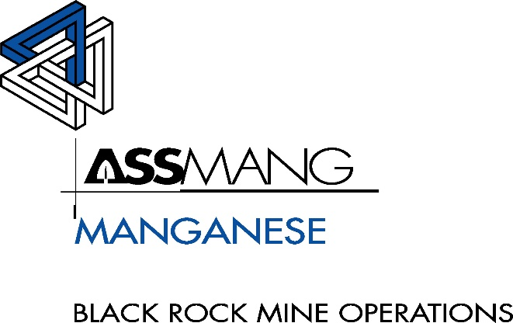

**Memorandum**

**To:** Senior General Manager

POSTAL ADDRESS:

P.O. BOX 187

8491, SANTOY

SOUTH AFRICA

TEL:

(27 53) 751 5555

FAX:

(27 53) 751 5251

**CC:** Finance Manager, HR Manager

**From:** G Karsten

**Date:** 02/10/2025

**RE: Appointment of 2x Junior Project Engineers**

**1) Introduction and Background**

BRMO is entering a critical phase of project execution in several projects. Current engineering resources are stretched, and there is a high risk of project delays, compliance violations, and production impacts. The addition of two Junior Project Engineers (JPEs) will strengthen field and coordination capacity, enabling senior engineers to remain focused on operational priorities while ensuring projects are delivered on schedule and to the required standard. To secure delivery of legal and operational projects, the appointment of two experienced JPEs at C5 level for a 12 month fixed term is strongly recommended.

**2.1 CAS Project — Q4 Close‑Out (Deadline: December 2025)**

We are in the final quarter with a fixed December deadline. The remaining scope includes completing CAS installations and activations on Level 9, commissioning tests, and coordination of underground activities with Mine personnel, OEM, and Strata. Tasks include vehicle scheduling, monitoring progress, sign‑offs, and defect corrections. JPEs will directly support the Lead Project Engineer (Hennie van Niekerk) to ensure crews and logistics stay on track. Scope covers Bell Dump Trucks (Surface), BWE Loaders (Surface), Aard UVs, Bell Scalers, and Mine Spec Cruisers at all three underground sites. Without additional capacity, the risk of overrun beyond December—and related production and compliance exposure—rises sharply.

**2.2 DPF Initiative — Regulatory Emissions Compliance (Multi‑Shaft Roll‑Out)**

New emissions legislation requires retrofitting over 300 diesel units across three underground sites with DPF and monitoring systems. This is a large, coordination‑intensive programme involving OEMs, third‑party installers, and Mine operations. JPEs will perform upfront engine emissions analysis, OEM/Supplier liaison, and day‑to‑day execution tasks: aligning vendor schedules with fleet availability, preparing documentation, tracking completions, and keeping auditable installation and test records. Without adequate resourcing, the project risks delays, non‑compliance, vendor standby costs, and production disruptions.

**2.3 Shaft & Surface Support — Relieving Production Engineers**

Production engineers face growing pressure from both statutory duties and projects. JPEs will assist with execution of selected shaft and surface projects (e.g., BEV bay fire‑door installations), alleviating pressure and freeing production engineers to concentrate on safety and production. They will also act as relieving engineers when required, ensuring continuity.

**3) Key Functions**

* Liaise with BRMO CAS Engineer on project plans and schedules
* Communicate schedules to production and maintenance teams
* Coordinate with planners, foremen, and MOs on access and scheduling
* Manage testing and commissioning of CAS Level 9 systems with OEM, Strata, and Mine personnel
* Compile documentation, records, and sign‑offs
* Assist with planning and capital applications
* Prepare reports and presentations
* Support production engineers on strategic projects
* Act as relieving engineer when required

**4) Competency and Experience Requirements**

* BEng/BSc/BTech (Mech/Elect/Industrial)
* 2–3 years’ experience, in mining / engineering projects
* Experience in maintenance or projects in a mining/plant environment is advantageous
* GCC Mines & Works advantageous
* Skills: project planning, coordination, risk assessment, QA/QC documentation, reading OEM drawings, change management, MS Project, Excel, Word, PowerPoint, Familiar with BRMO processes.

**5) Appointment and Reporting**

* Reporting line: Senior Production Engineer
* Direct project reporting to CAS or relevant Production Engineer
* Appointment: Junior Project Engineer, C5 band (Foreman level)

**Conclusion and Recommendation**

The project portfolio at BRMO—especially the CAS close‑out and DPF initiative—requires additional project management and coordination capacity. The appointment of two Junior Project Engineers will provide the field, coordination, and documentation support required to deliver projects successfully, ensure compliance, and allow engineers to focus on their core responsibilities. Approval is therefore requested for two JPE appointments at C5 level with immediate effect for a period of 12 months.

Requested by:

**G G Karsten**

**Senior Production Engineer**

**Approved by:**

|  |  |  |
| --- | --- | --- |
| **Sign:** | **Sign:** | **Sign:** |
| **HR Manager** | **Finance Manager** | **Senior General Manager** |
| **HRM: T. Gxotelwa** | **N Ramlugan** | **R Opperman** |